**KINDERGARTEN**

* 1 Art smock (large button-down shirt or t-shirt)
* 24 #2 Sharpened Ticonderoga brand pencils with erasers (DO NOT LABEL)
* 2 - 12-Count boxes of Crayola colored twistable pencils (not scented) (12 count only)
* 1 - 6pk Chisel tip primary color low odor Expo dry erase markers (not skinny)
* 1 Expo Dry eraser
* 2 - 8 Color Crayola watercolor paint sets
* 2 Boxes of 24 count Crayola crayons (not scented)
* 2 Boxes of CraZArt or Crayola 10 classic colors washable markers (not skinny, label with child’s initials)
* 8 Glue sticks
* 1 Pair child scissors
* 1 - 8 x 5 Pencil case
* 1 Ruler (inches only needed)
* 1 Pkg 50 sheet colored construction paper
* 1 Red plastic pocket folder
* 1 Orange plastic pocket folder
* 2-Two-inch 3-ring binders with clear cover jacket

(no trapper keepers)

* 2 Packages of 5-page dividers for 3-ring binders
* 1 Package of 20 plastic page protectors
* 1 Set of Velcro gym shoes to keep at school
* 1 Emergency pack of clothing (white shirt, blue bottom, 2 pairs of underwear, 2 pairs of socks)
* 2 Rolls of paper towels
* 3 Boxes of tissue
* 1 Box of sandwich Ziploc bags
* 1 Box of gallon size Ziploc bags
* 1 Lunch box labeled with student’s name
* 1 Reusable water bottle labeled with student’s name
* 1 Picture of your child
* Phonogram Cards $17.00 (Phonogram cards will be ordered through the school)
* 1 Toddler Nap Set, comes with attached pillow and blanket (example below)

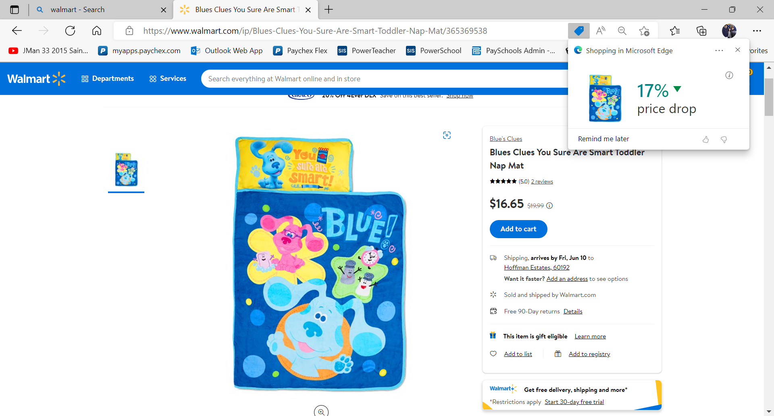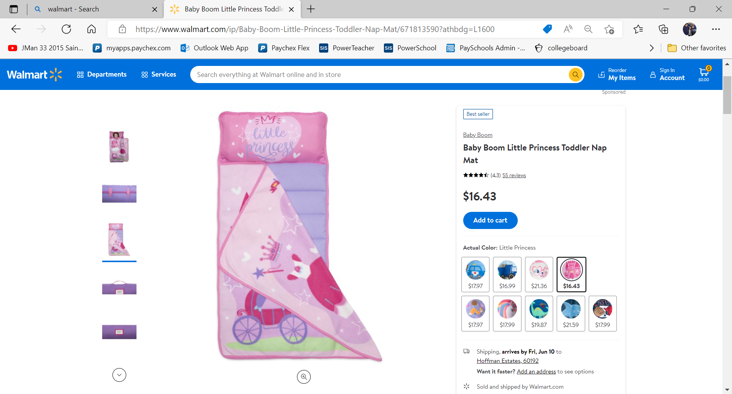

**All supplies must be labeled except for pencils, dry erase markers & glue sticks.**