**K4**

* 1 Art smock (large button-down shirt or oversized t-shirt)
* 1 Box of 10 pk CraZArt or Crayola fat washable markers
* 1 Crayola 8 ct. washable watercolor paints
* 4 Boxes 24 count Crayola crayons
* 1 Pencil box
* 1 Pack of 4 pk Expo Dry Erase skinny markers
* 1 Red plastic pocket folder
* 4 Elmer’s glue sticks
* 1 – 2 1/2” binder with clear jacket cover
* 1 Set of 8 notebook dividers
* 1 Pack of 25 count plastic sheet protectors
* 1 Lunchbox (labeled)
* 4 Tissue boxes
* 1 Large container of disinfectant wipes
* 2 Rolls of paper towels
* 1 Reusable water bottle (labeled)
* 1 Box of sandwich sized Ziploc bags
* 1 Box of gallon sized Ziploc bags
* 2 Extra sets of pants, shirts, underwear & socks

(Labeled in Ziploc bag to keep inside cubby)

* Velcro gym shoes - to keep at school
* 1 Picture of your child
* 1 Toddler Nap Set, comes with attached pillow and blanket (example below)

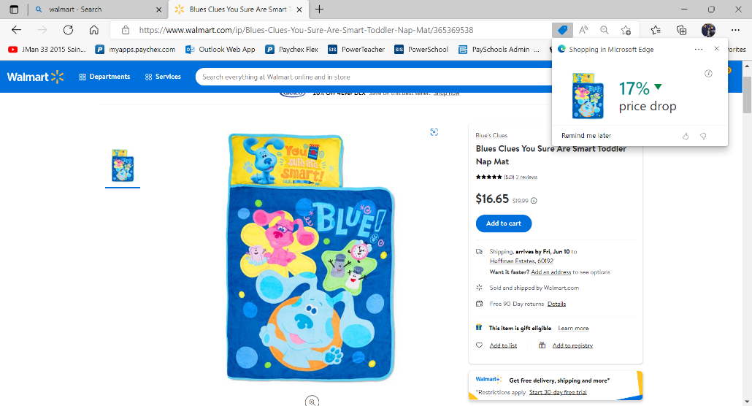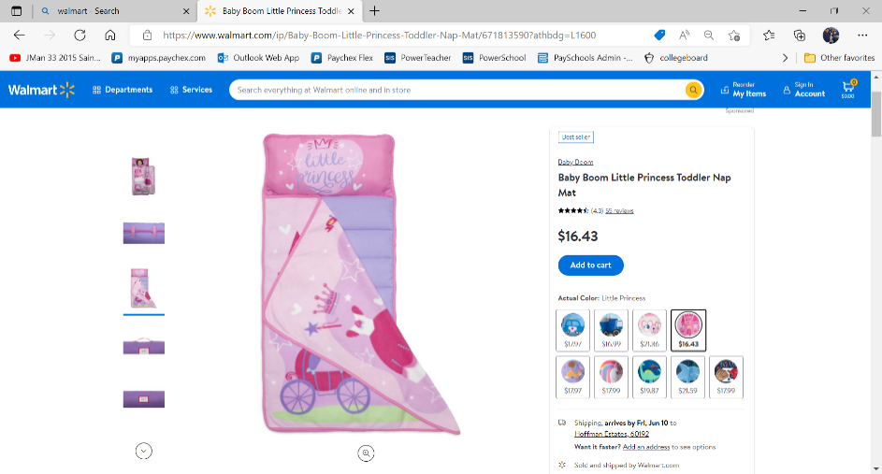

**All supplies must be labeled, as they will not be shared amongst students.**